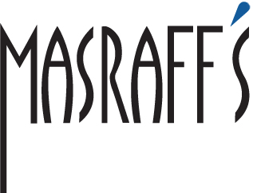

Mother’s Day Brunch
May 13, 2018

FIRST COURSE
Garlic Seared Calamari
Oyster Mushroom, Shaved Onion, Cilantro, Soy Reduction

Shrimp and Romaine Salad
Romaine Lettuces, Poached Shrimp, Shaved Red Onions, Roma Tomatoes, Avocado, Mango
Garlic Vinaigrette and Reggiano Cheese

Chicken Tortilla Soup
Garnished with Diced Avocado, Shredded Cheddar Cheese, and Crispy Tortilla Strips
Crab Stuffed Mushrooms
Crab and Mascarpone Cheese Stuffed Cremini Mushrooms with Remoulade and Purple Basil Sauce

Duck Spring Rolls
Duck Confit, Rice Noodles, and Green Cabbage Wrapped in Rice Paper with Sweet Chili and Soy Sauce

ENTRÉE
Wild King Salmon
Shrimp and Red Bell Pepper Infused Italian Polenta, Saffron White Asparagus, Baby Arugula
Sun-Dried Tomato and Fried Caper Beurre Blanc

Pan Seared Alaskan Halibut
Lobster and Wild Ramp Risotto, Crab and Beet Relish, Roasted Hedgehog Mushrooms, and Bourbon Lobster Sauce

Shrimp, Poblano, and Brie Omelet
Venison Sausage and Fingerling Potato Hash, Garnished with Fried Tortilla Strips, Sour Cream and Tomato Relish

6 oz. Filet Mignon
Shrimp and Bacon Mac and Cheese, Roasted Morell Mushrooms and Shallots, Finished with Foie Gras Demi Glaze

Oven Roasted Australian Rack of Lamb
Crab and Roasted Poblano Infused Potato Puree, Charred Romanesco, and Cabernet Sauvignon Rosemary Reduction

DESSERT
Fresh Blueberry Tart
Raspberry Mousse and Mango Coulis

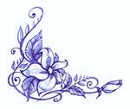
Bananas Foster Pudding
Phyllo Dough Shell filled with Bananas Foster and Banana Cream
Finished with Mango Sauce

Kahlua Creme Mousse
Decadent Kahlua and Vanilla Pastry Crèmes
Topped with Fresh Strawberries and a Dark Chocolate Drizzle

Chocolate Fondant
Vanilla Bean Ice Cream and Crème Anglaise

Tres Leches
Layers of Vanilla Sponge Cake soaked in 3 Milks
Topped with Fresh Strawberries and Whipped Cream

